Step 1:  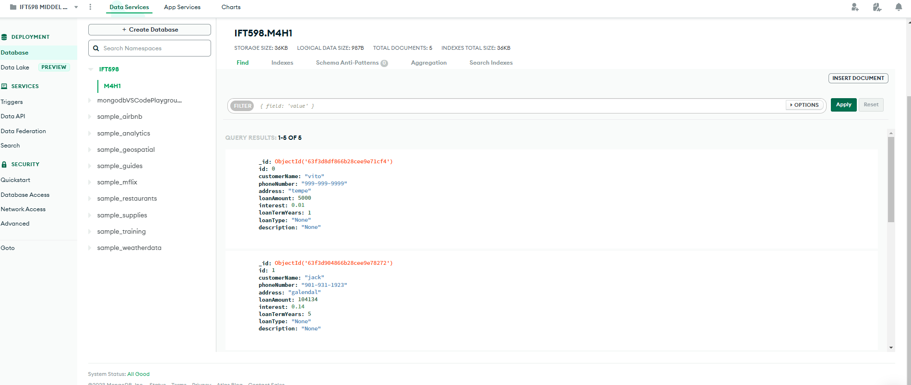

Step 2:

Step3:

Step 4:

Models are compiled from definitions. An instance of a model is called a document. The model is responsible for creating and reading documents from the MongoDB database. once the schema is defined, it needs to transform our schema into a model. SchemaTypes are:String,Number,Date,Buffer,Boolean,Mixed,ObjectId,Array,Decimal128,Map.

Step5:

Step6:

